To: The unknown owners, lessees, tenants or occupiers of this land and the subsoil of this land described and shaded red on the accompanying plan and anyone with an interest in it or with the power to sell, convey or release it or people who could have a claim for compensation as a result of the below noted project going ahead.

Orsted Hornsea Project Four Limited, of 5 Howick Place, London, SW1P 1WG (hereafter referred to as ‘the Applicant’) intends to apply to the Secretary of State for a Development Consent Order (DCO) under Section 37 of the Planning Act 2008 for the construction, operation, maintenance and decommissioning of an offshore wind farm generating station, and to connect the wind farm to the national grid (‘Hornsea Four’).

The Applicant are proposing to develop an offshore wind farm in the North Sea, which will involve the installation of new offshore wind turbines located in the "array area", which has a total area of 492 km² and is located approximately 65km east of Flamborough Head on the Yorkshire coast.
The electricity generated from Hornsea Four will be transmitted via subsea electricity cables. The Hornsea Four offshore cable corridor extends from the southwestern boundary of the array area in a west-south-westerly direction to the East Riding of Yorkshire coastline. From the East Riding of Yorkshire coast, underground onshore cables will connect the offshore wind farm to an onshore high voltage direct current (HVDC) converter station or a high voltage alternating current (HVAC) substation, which in turn, will connect to the existing Creyke Beck National Grid substation, located to the north of Cottingham. The mode of transmission will be either HVDC, HVAC or a combination of the two. Depending on the mode of transmission, a HVAC booster station may be required (onshore and/or offshore). The onshore cable corridor search area currently comprises an 80m wide corridor within which a 60m onshore cable corridor permanent easement will be located.
The development of Hornsea Four may affect the land identified in this notice. The Applicant has been unable to identify all rights in and ownership of the land and sub soil of the land shown shaded in red on the attached plan. Pursuant to Section 42 of the Planning Act 2008 we are seeking to consult people who may have an interest in this land, including owners, tenants, lessees or occupiers of the land or persons with the power to sell, convey or release the land, or people who could have a claim for compensation as a result of Hornsea Four going ahead.

This notice is therefore intended to inform anyone who may have a relevant interest (under section 42 of the Planning Act 2008) in the land as set out above of the consultation to seek their views. Please note that this consultation phase pursuant to Section 42 of the Planning Act 2008 closes on 8 September 2020.

If you believe you have a relevant interest then we should be grateful if you would contact Orsted using the contact details set out below as soon as possible quoting reference on the accompanying plan.
- Email: hornseaprojectfour@orsted.co.uk
- Write to: Hornsea Project Four Offshore Wind Farm, Orsted, 5 Howick Place, London, SW1P 1WG
Hornsea Four is “EIA development” for the purposes of The Infrastructure Planning (Environmental Impact Assessment) Regulations 2017. The proposed application for a DCO will therefore be accompanied by an Environmental Statement (ES). The proposed DCO will also seek the compulsory acquisition of land and rights over land, including the power to take temporary possession of land to construct and maintain Hornsea Four.

Further details can be found on the Hornsea Four website https://hornseaprojects.co.uk/en/Hornsea-Project-Four or requested from the email or postal addresses below. Any responses to, or other representations in respect of, Hornsea Four should be sent to the Applicant, by email to hornseaprojectfour@orsted.co.uk or by post to Hornsea Project Four Offshore Wind Farm, Orsted, 5 Howick Place, London, SW1P 1WG.

Any response or representation in respect of the proposed DCO must (i) be received by the Applicant no later than 8 September 2020, (ii) be made in writing, (iii) state the grounds of the response or representation, (iv) indicate who is making the response or representation, and (v) give an address to which correspondence relating to the response or representation may be sent. Responses and other representations may be made public.

Documents, plans and maps showing the nature and location of Hornsea Four and including the preliminary environmental information report are available to view in the Documents Library on the Hornsea Four website: https://hornseaprojects.co.uk/hornsea-project-four/documents-library/formal-consultation

For any enquiries in relation to any documents, plans or maps relating to Hornsea Four you can contact Orsted on 0808 169 3030 or using the email address or postal address listed in this notice.

Reference: <<ParcelNumber>>

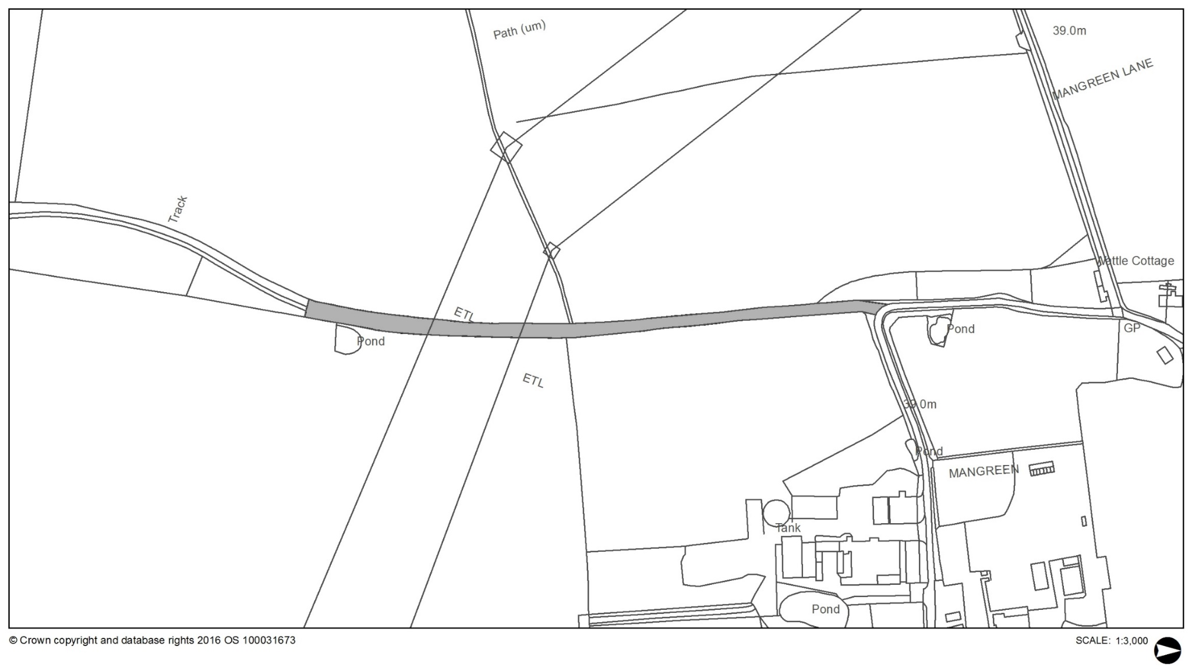
Land Description: <<ParcelDescription>>

